

**How to install Office365 (Laptop)**

1. Open a web browser and type ‘office.com’ in the address bar.
2. Click ‘Sign in’.

1. Enter your St Hilda’s email address

1. Enter your St Hilda’s password.

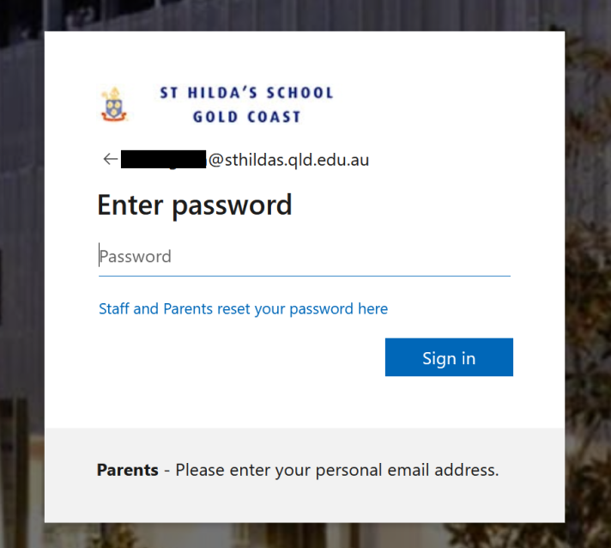

1. Then click on ‘Install apps’ located top left of the screen

1. The installer will download to your downloads folder. Double-click the OfficeSetup installer to begin the installation.
2. The installation will take around 10 mins.   
   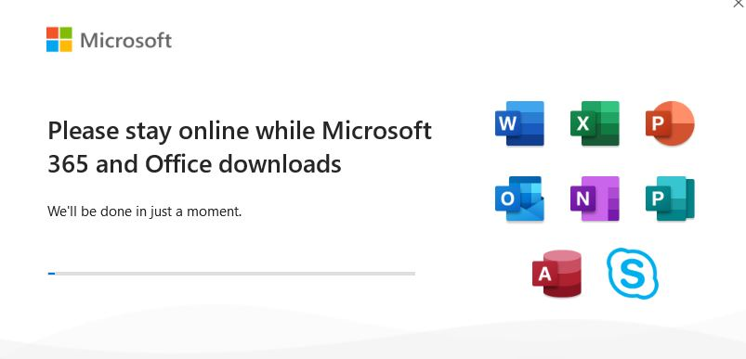
3. Please restart your device after the installation has been completed.

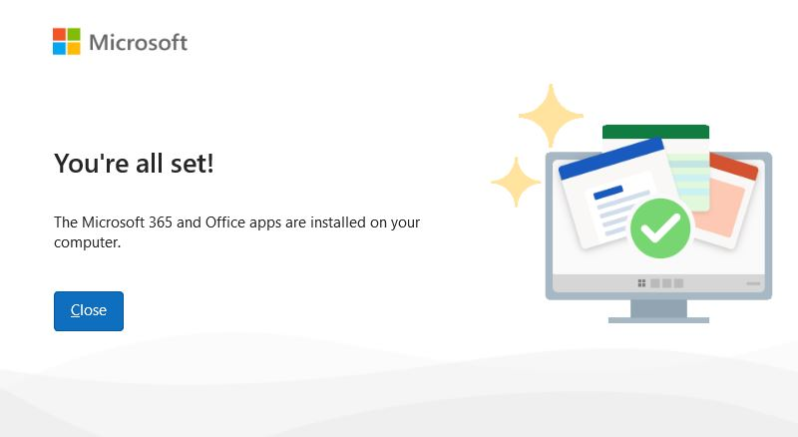

1. You will now have office Applications installed on your laptop! They will all appear in the applications folder on Mac and in start menu on Windows.

