Teacher Kiosk Troubleshooting - Changing Default Browser to Chrome

1. Click on the Window icon in the lower left of your screen  
http://shsjitbit01/helpdesk/File/Get/2421  
  
2. Click on the settings cog  
http://shsjitbit01/helpdesk/File/Get/2422  
  
3. Click on the Settings icon  
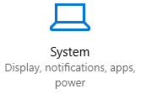  
  
4. Click on the Default apps icon  
http://shsjitbit01/helpdesk/File/Get/2424  
  
5. Click on the Web Browser icon (click where it shows what browser you are currently using. In the example below, I am using Internet Explorer)  
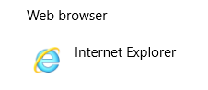  
  
6. Click on Google Chrome to change the default browser. This will now open Chrome for any links etc.  
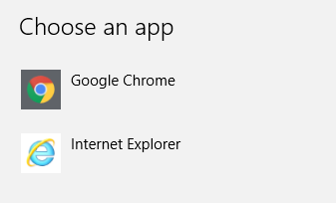  
  
Now, you can click the Teachers Kiosk link and it will work.